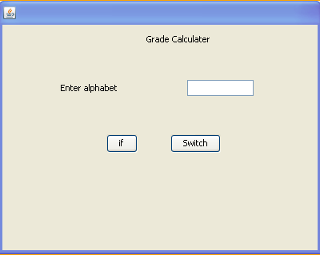
private void jButton1ActionPerformed(java.awt.event.ActionEvent evt) {
int percentage=Integer.parseInt(alphabet.getText());
if(percentage>=90)
JOptionPane.showMessageDialog(null,"A");
if((percentage>=70)&&(percentage<=90))
JOptionPane.showMessageDialog(null,"B");
if((percentage>=40) &&(percentage<=70))
JOptionPane.showMessageDialog(null,"C");
else
JOptionPane.showMessageDialog(null,"D");
}

private void jButton2ActionPerformed(java.awt.event.ActionEvent evt) {
int percentage=Integer.parseInt(alphabet.getText());
switch (percentage){
case 1:
JOptionPane.showMessageDialog(null,"A");
break;
case 2:
JOptionPane.showMessageDialog(null,"B");
break;
case 3:
JOptionPane.showMessageDialog(null,"C");
break;
case 4:
JOptionPane.showMessageDialog(null,"D");
break;
default:
JOptionPane.showMessageDialog(null,"Fail");
break;
}

